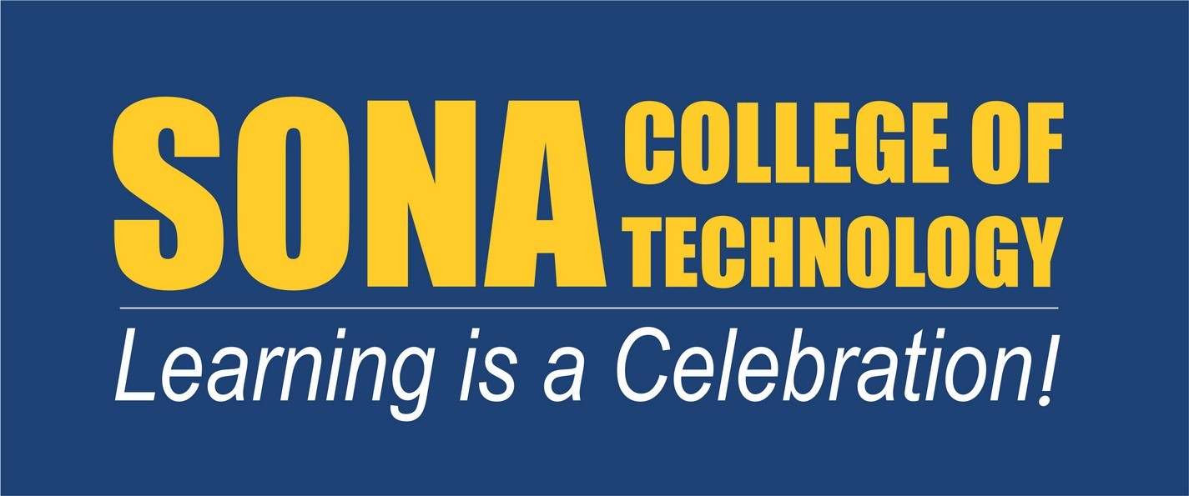

**REPORT OF EVENT ORGANIZED THROUGH**

# NCC 2018 - 2019

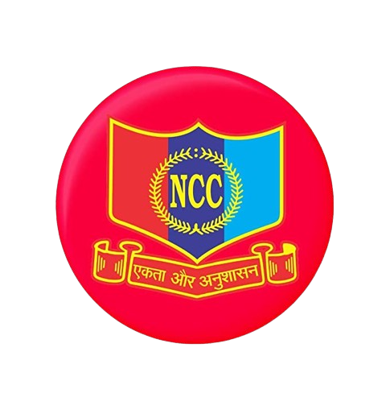

**NATIONAL CADET CORPS**

1. **TN SIG COY NCC, SALEM**
2. **TN BN NCC, SALEM**

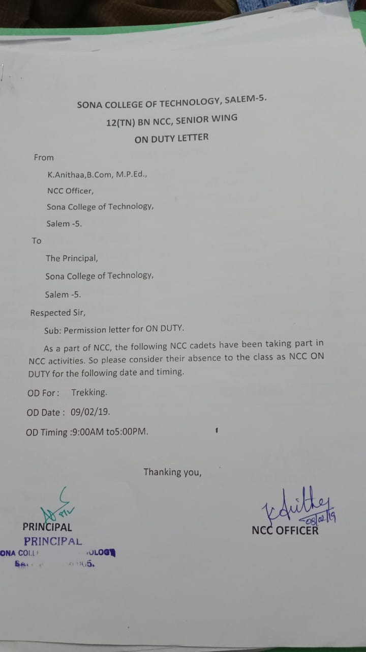

**Sona College of Technology, Salem**

**(An Autonomous Institution)**

**National Cadet Corps**

|  |  |  |  |  |
| --- | --- | --- | --- | --- |
| **S NO** | **REGT NO** | **NAME** | **SIGN** | **REMARKS** |
| 01. | TN16SDA866201 | SARAN RAM KC |  |  |
| 02. | TN16SDA866202 | PRAVEENKUMAR V |  |  |
| 03. | TN16SDA866203 | SARAVANAVEL V |  |  |
| 04. | TN16SDA866204 | VARATHARAJAN R |  |  |
| 05. | TN16SDA866205 | VIGNESHWAR N |  |  |
| 06. | TN16SDA866206 | JAGATHESH S |  |  |
| 07. | TN16SDA866207 | BHUVANESHWARAN K |  |  |
| 08. | TN16SDA866208 | THIRUPATHI R |  |  |
| 09. | TN16SDA866209 | KISHOREKUMAR K |  |  |
| 10. | TN16SDA866210 | MANO RANJITH J |  |  |
| 11. | TN16SDA866211 | SASIPREETHAM B |  |  |
| 12. | TN17SDA866202 | GOLLAPROLU SUBHASH VARUN |  |  |
| 13. | TN17SDA866203 | KARTHIKEYAN T |  |  |
| 14. | TN17SDA866204 | KARTHIKEYAN T |  |  |
| 15. | TN17SDA866205 | MOHAMMED  HARISH S |  |  |
| 16. | TN17SDA866206 | NAVEEN R |  |  |
| 17. | TN17SDA866207 | NITHISH KUMAR R |  |  |
| 18. | TN17SDA866208 | NITHIS KUMAR R |  |  |
| 19. | TN17SDA866209 | ORSU SANDEEP |  |  |
| 20. | TN17SDA866210 | PRAVEEN RAJAN S |  |  |
| 21. | TN17SDA866211 | RAGULPRABAKARAN R |  |  |
| 22. | TN17SDA866212 | SAKTHIVEL V |  |  |
| 23. | TN17SDA866213 | ULAVAPATI PRADEEP |  |  |
| 24. | TN16SWA832502 | DIVYABHARATHI G |  |  |
| 25. | TN16SWA832503 | DURGADEVI A |  |  |
| 26. | TN16SWA832504 | GAYATHRI K |  |  |
| 27. | TN16SWA832505 | INDUMATHI MP |  |  |
| 28. | TN16SWA832508 | KANMANI  KARTHIGA S |  |  |
| 29. | TN16SWA832510 | KAUSIKA D |  |  |
| 30. | TN16SWA832511 | NANDHINIPRIYA A |  |  |
| 31. | TN16SWA832517 | SRUTHI S |  |  |
| 32. | TN16SWA832518 | SWETHA S |  |  |
| 33. | TN16SWA832519 | UNMAI VK |  |  |
| 34. | TN17SWA832501 | AARTHI S |  |  |
| 35. | TN17SWA832505 | INDHIRAJOTHI S |  |  |
| 36. | TN17SWA832506 | JANANI R |  |  |
| 37. | TN17SWA832509 | KAVYA S |  |  |
| 38. | TN17SWA832514 | SAHANA R |  |  |
| 39. | TN17SWA832515 | SANGEETHA SRI K J |  |  |
| 40. | TN17SWA832516 | SARALA R |  |  |
| 41. | TN17SWA832517 | SHALINI ASHOK |  |  |
| 42. | TN17SWA832519 | SHOBIGAA.P. J |  |  |
| 43. | TN18 SWA832508 | DHIVYA SHREE.S |  |  |
| 44. | TN18 SWA832510 | GOPIKA.I |  |  |
| 45. | TN18 SWA832516 | KAVIPRIYA.R |  |  |
| 46. | TN18 SWA832517 | KAVIYA.S |  |  |
| 47. | TN18 SWA832525 | SHANMUGAPRIYA.S |  |  |

**ANO / CARE TAKER**

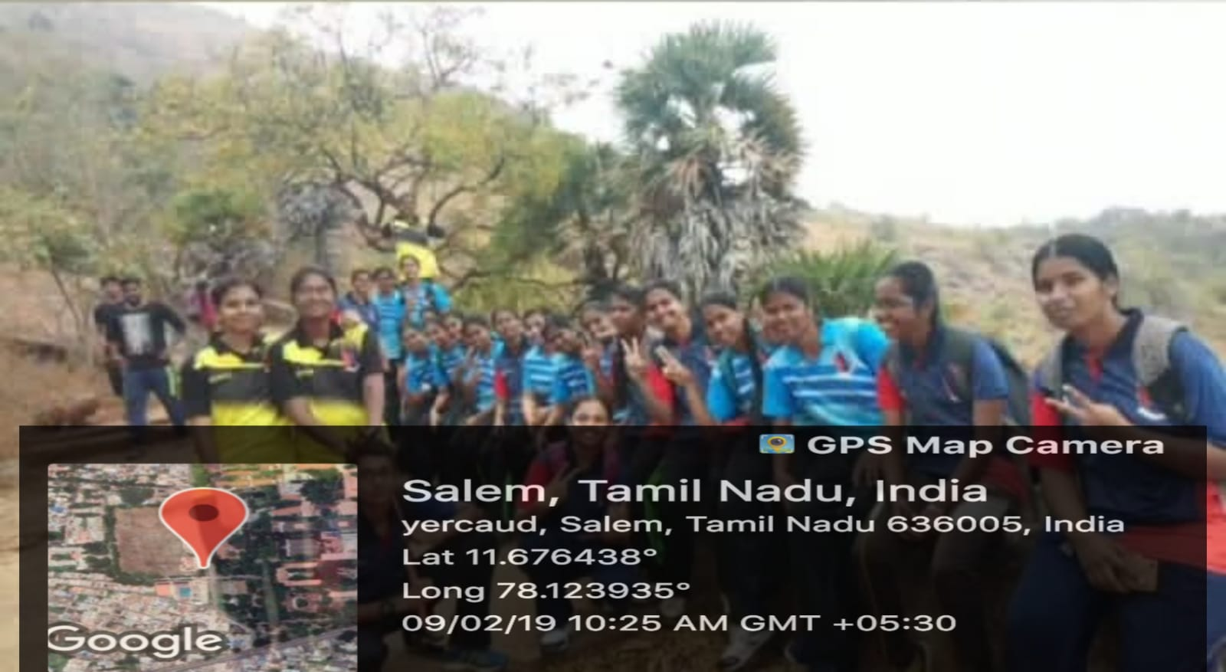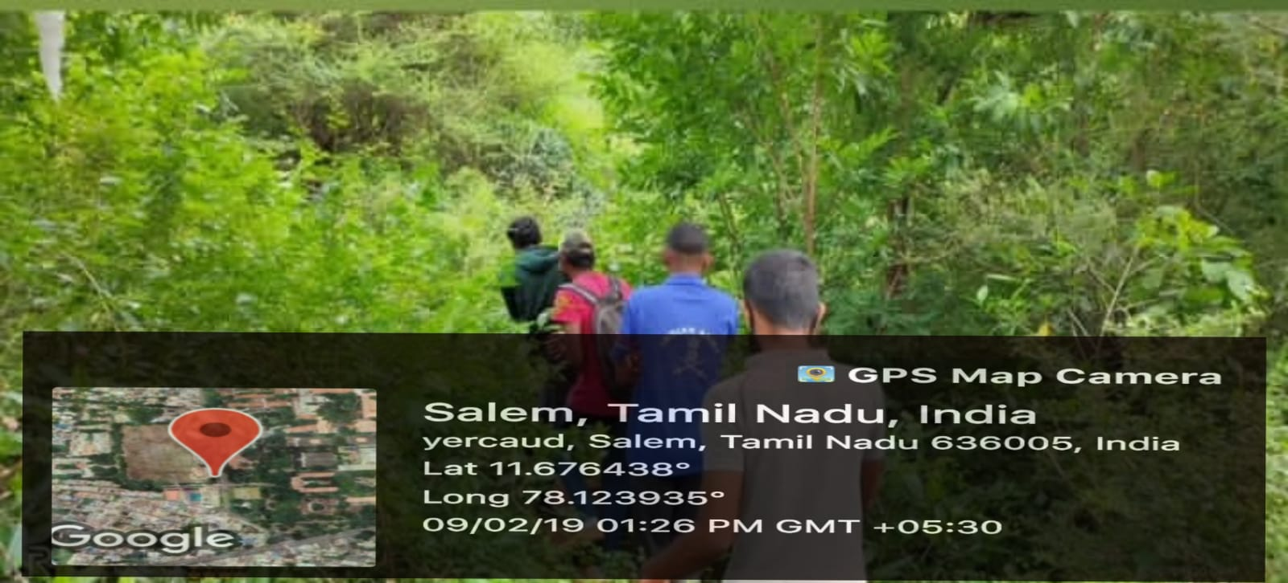

**TREKKING – NCC CADETS VISITED YERCAUD**

**TREKKING**

A visit to Yercaud was organised by the NCC cadets by themselves. As a part of adventurous activities we went for trekking on the nearby hill. It was a joyful experience. Trekking is similar to meditation, when we climb up to the mountain peak it calms our mind and makes us feel fresh. You get a great connection with nature through these adventurous activities. We all had a thrilling experience. Trekking helps us live in the present moment and improves our mood, and decreases anxiety and even helps in memory retention. The whole experience of trekking on less visited trails is extremely refreshing and mentally relaxing.

Overall, 24 SW cadets from Sona college of Technology have participated in this event which was held on 9th February 2019. Our cadets represented as volunteers for this event and, this made a great impact among ourselves as we enjoyed a lot.

**Name of the organization:** 11 TN SIG COY, 12 TN BN NCC with Sona NCC

**Number of participations:** 47

**Dated:** 09/02/2019